Finding the right school for your child is one of the most tedious tasks for our parents in this city. Since it is because the future of kids is involved in it. People who are living in Whitefield may want to explore **schools near Whitefield** there will be lots and lots of confusion revolving around our parents.

Whitefield is known for its IT Hubs. Professionals from all over India are staying here to explore **schools near Whitefield** for their children since they want their kids not to send their kids so far away. Hence, we have listed some of the Top 10best **schools near Whitefield,** Bangalore.

1. **Harvest International school :**

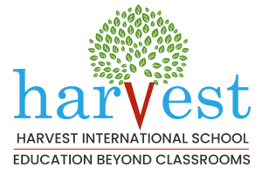

* Harvest International is the first best international school which comes to my mind while writing this blog.
* Harvest International, a **school near Whitefield** offers an unconventional education which is beyond the walls of the classroom and shows and gives a life experience for kids about the real world.
* Keeping the national and global context of the school in mind Harvest International provides a well-diversified education with an innovative culture of learning which in turn harvest the belief that it is a “ Way of life”.
* Harvest provides an in-house developed curriculum which in turn merges CBSE with IB teaching methodologies which is a key thing harvest stand tall apart from the **schools near Whitefield.**
* Apart from academics Harvest also provides sports, craft, and performing arts facilities with well-equipped trainers and infrastructure .
* They also have a strong R & D team which in turn used to continuously expand and modify their teaching approaches.

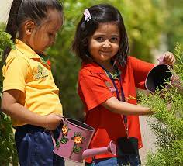

**Why choose Harvest for your Kid?**

* A most reputable Cbse **school near Whitefield**
* Outstanding educational facilities
* Using cutting-edge technology
* Affordable cost for higher education
* Better opportunities for your child’s career.

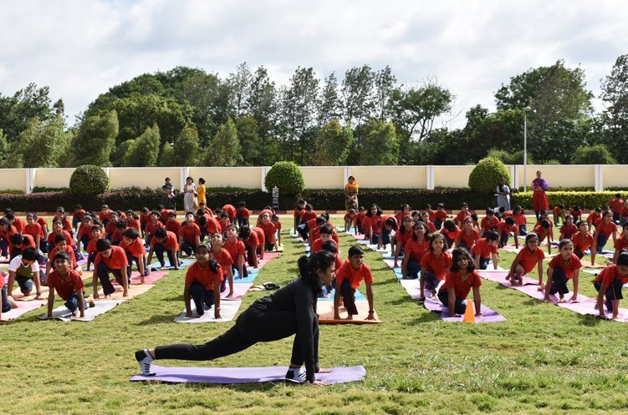

**Awards and Recognition by Harvest International**

When it comes to a well-recognized school in Karnataka, Harvest stands top of the list. Some of their recognitions are

* INDIA’s Top CBSE school – Parameter wise
* INDIA school Merit awards
* FIT India Certificate – Government of India
* Global sustainable school awards 2017
* Asia Education Summit & Awards 2017
* INDIA Top CBSE School – Parameter wise

1. **Deens Academy:**

* Deens one of the **schools near Whitefield** follow CBSE Syllabus and provide classes from KG to the secondary level.
* The school believes in incorporating various interesting ways of teaching, such as play methods, live projects, experiments and more, in addition to the regular textbook teaching.
* It also maintains qualities that help children grow into responsible, independent children.

1. **Vydehi School of Excellence**

* Vydehi school emphasizes experiential learning to make lessons more engaging and easy to understand.
* In addition to the regular classes, it also offers various co-curricular activities to its students. Some such activities include art and crafts , dance and music, clay modelling, pottery making, field trips, chess, story-telling and more.
* It is one of the schools near Whitefield that balances scholastic and co-scholastic activities

1. **Vibgyor High School:**

* This school has 11 branches in Karnataka, where one of the **schools near Whitefield.**
* It focuses on the wholesome development of every child through an integrated learning program and a variety of activities.
* It is one of the schools in Whitefield Bangalore that aims to make learning a creative and enjoyable experience.

1. Maple bear Canadian School:

* It is a unique school that offers programs to children ages 18 months to 8 years.
* As the name suggests, it brings in international expertise and early learning programs to help children start their educational journey on the right note.
* Instead of only focusing on a particular board or way of teaching this school believes in enhancing the overall personal as well as academic level of the students.

1. **Whitefield Global School:**

* As the name says that it is a **school near Whitefield.**
* The school follows the CBSE pattern of teaching for all its classes and offers education from pre-primary to the high school level.
* The school provides its students with extracurriculars like clay art, pottery making, mask making, art and craft, dance and music etc.,

1. **Glentree Academy**

* They have a holistic curriculum that includes extra-curricular activities, sports, and academics to ensure balanced learning.
* The school follows the CBSE pattern of the syllabus for all its classes, from Nursery to senior.
* In addition to regular academics, the school offers a host of extra-curricular activities such as yoga, vocal and instrumental music, theater, painting, and gardening.